ASSIGNEMENT- sarang rampal

**Problem 1: Counting Vowels**

Write a Python function count_vowels that takes a string as input and returns the number of vowels in the string. For this problem, assume that the vowels are a, e, i, o, and u.

https://replit.com/@sarang1708/a-e-i-o-u#main.py

Output:

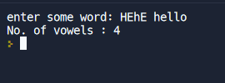

2.#Write a program that prints the numbers from 1 to 100. But for multiples of three, print "Fizz" instead of the number and for the multiples of five, print "Buzz". For numbers which are multiples of both three and five, print "FizzBuzz"

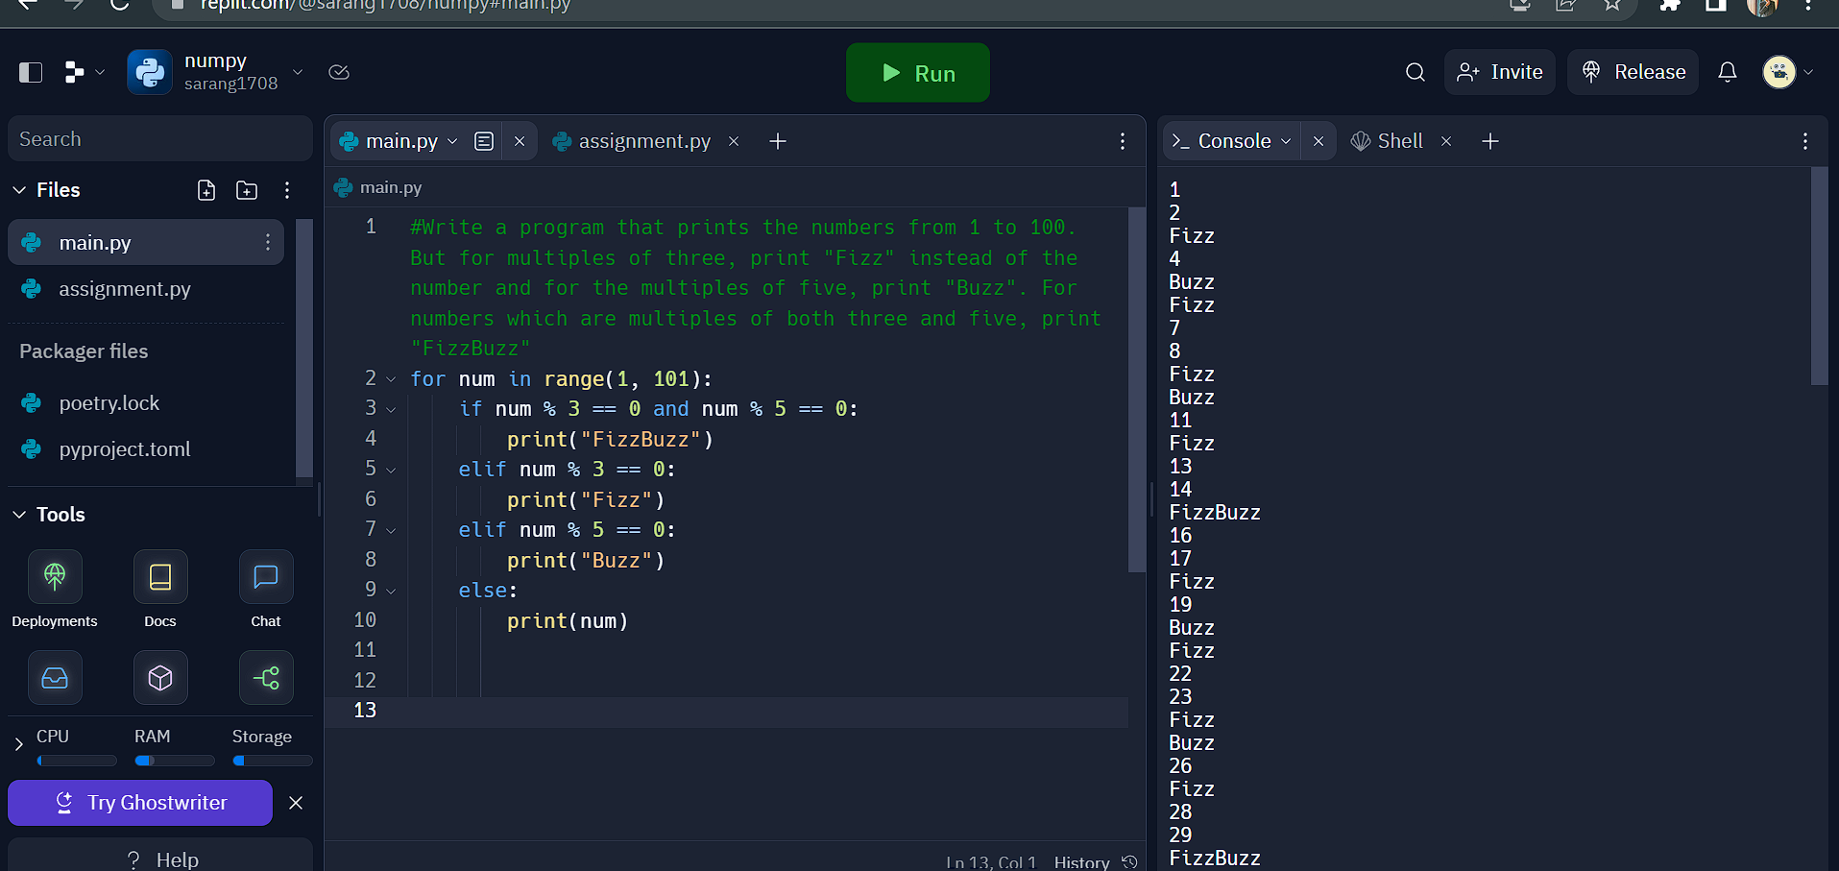

3.Write a Python function is_palindrome that takes a string as input and returns True if the string is a palindrome and False otherwise. For this problem, ignore spaces and capitalization when determining if the string is a palindrome.

https://replit.com/@sarang1708/sarang1708#main.py

Output:  
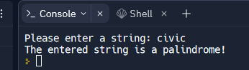

**Problem 4: Fibonacci**

Write a Python function fibonacci that takes a number n as input and returns the nth number in the Fibonacci sequence. The Fibonacci sequence is defined as follows:

The first two numbers in the sequence are 0 and 1.

Every subsequent number is the sum of the two preceding numbers.

https://replit.com/@sarang1708/sarang-fibonacci#main.py

Output:

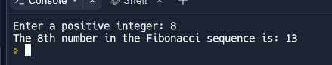

Problem 5: Largest Element

Write a Python function largest_element that takes a list of numbers as input and returns the largest element in the list.

https://replit.com/@sarang1708/largest-element#main.py

Output:

